Title in English (Times New Roman; size-14; Interline 1,15)
العـنـوان باللغة العربية (الخط: Sakkal Majalla، حجم الخط 16، تباعد أسطر 1,15)

Full name of the first author ¹, Full name of the second author ²
الإسم الكامل للباحث الأول¹، الاسم الكامل للباحث الثاني²
¹ Full affiliation (Country), professional e-mail of researcher
² Full affiliation (Country), professional e-mail of researcher
Received: .../…/2026 Accepted: .../…/2026 Published:30/06/2026

Abstract: (Do not exceed 150 words)
Enter your abstract here (an abstract is a brief, comprehensive summary of the contents of the article). Enter your abstract here (an abstract is a brief, comprehensive summary of the contents of the article).
Enter your abstract here (an abstract is a brief, comprehensive summary of the contents of the article). Enter your abstract here (an abstract is a brief, comprehensive summary of the contents of the article).
Keywords: keywords; keywords; keywords; keywords; keywords.
JEL Classification Codes: …, …, …
ملخص: (150 كلمة على الأكثر)
يوضع الملخص هنا (يتم الإشارة في الملخص إلى هدف البحث، والنتائج المتوصل إليها في فقرتين). يوضع الملخص هنا (يتم الإشارة في الملخص إلى هدف البحث، والنتائج المتوصل إليها في فقرتين). يوضع الملخص هنا (يتم الإشارة في الملخص إلى هدف البحث، والنتائج المتوصل إليها في فقرتين). يوضع الملخص هنا (يتم الإشارة في الملخص إلى هدف البحث، والنتائج المتوصل إليها في فقرتين). يوضع الملخص هنا (يتم الإشارة في الملخص إلى هدف البحث، والنتائج المتوصل إليها في فقرتين).
كلمات مفتاحية: ك. م.، ك. م.، ك. م.، ك. م.، ك. م.
تصنيفات JEL: ....،.....،.... وضع ترميز JEL إجباري

__________________________________________

Corresponding author: Full name, e-mail: authorC@mail.com.

1. Introduction
The first subtitle opens with an introduction that presents the specific problem under study and describes the research strategy. The first subtitle opens with an introduction that presents the specific problem under study and describes the research strategy. (Times New Roman 14, interline 1.15)

2. Title
2.1 First Subtitle
Enter here the text of first subtitle, Enter here the text of first subtitle, Enter here the text of first subtitle, Enter here the text of first subtitle, Enter here the text of first subtitle, Enter here the text of first subtitle, Enter here the text of first subtitle.
2.2 Second Subtitle
Enter here the text of second subtitle, enter here the text of second subtitle, enter here the text of second subtitle, enter here the text of second subtitle, enter here the text of second subtitle, enter here the text of second subtitle, enter here the text of second subtitle.

3. Title
3.1 First Subtitle
Enter here the text of first subtitle, Enter here the text of first subtitle, Enter here the text of first subtitle, Enter here the text of first subtitle, Enter here the text of first subtitle, Enter here the text of first subtitle, Enter here the text of first subtitle.
3.2 Second Subtitle
Enter here the text of second subtitle, enter here the text of second subtitle, enter here the text of second subtitle, enter here the text of second subtitle, enter here the text of second subtitle, enter here the text of second subtitle, enter here the text of second subtitle, enter here the text of second subtitle, enter here the text of second subtitle.

4. Results and Discussion
Enter your results in this section; summarize the collected data and the analysis performed on those data relevant to the discourse that is to follow. After presenting the results, you are in a position to evaluate and interpret their implications, especially with respect to your original hypotheses.

Table 01: Table title (this is an example of table 1)
Test 1 | Test 2 | Results 1 | Results 2 | Total Results

Source:

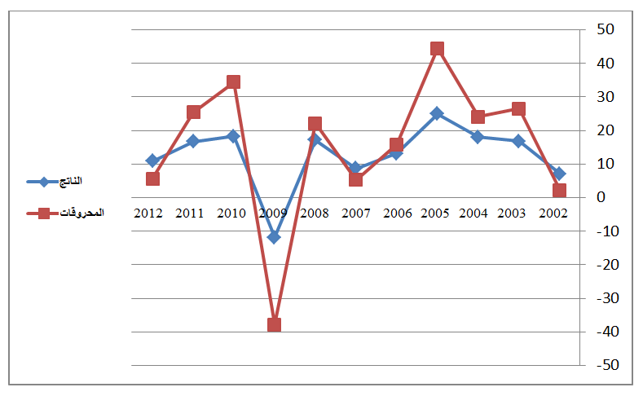
Fig.01: Figure title (this is an example of figure 1)

Source:

3. Experimental
This experimental section can be divided into subsections, the contents of which vary according to the subject matter of the article. It must contain all the information about the experimental procedure and materials used to carry out experiments.

4. Conclusion
The conclusion of a research paper needs to summarize the content and purpose of the article. The conclusion of a research paper needs to summarize the content and purpose of the article. The conclusion of a research paper needs to summarize the content and purpose of the article. The conclusion of a research paper needs to summarize the content and purpose of the article. The conclusion of a research paper needs to summarize the content and purpose of the article. The conclusion of a research paper needs to summarize the content and purpose of the article.

5. Bibliography List :
Use the « APA Reference System », see the link:
https://support.office.com/fr-fr/article/APA-MLA-Chicago-%E2%80%93-Mise-en-forme-automatique-de-bibliographies-405c207c-7070-42fa-91e7-eaf064b14dbb

The references must be directly quoted in the body of the text (eg: ... (Brown, 2006, p35), without omitting to mention the complete reference in the list of references at the end of the document, written in the following manner:
- Books : author’s name (year), full title, publishing, country;
- Theses: researcher (year), thesis title, college, university, country ;
- Journal article : author’s name (year), full title of the article, review name, place, volume and number, page ;
- Seminar article: author’s name (year), full title of the paper, title of seminar, place and date, country ;
- Internet websites: author’s name (year), full title of the file, detailed web site : http://fulladdress (consulted on day/month/year).

6. Appendices

