Title in English (Times New Roman; size-13; Interline 1,15)
العـنـوان باللغة العربية (الخط: Traditional Arabic، حجم الخط 15، تباعد أسطر 1,15)

Full name of the first author ¹, Full name of the second author ²*
¹ Full affiliation, Country, Email address, (Times New Roman; size-12)
 Authors’ ORCID ID Link (https://orcid.org/)
² Full affiliation, Country, Email address, (times new roman; size-12)
Authors’ ORCID ID Link (https://orcid.org/)

Received:00/00/2026 | Accepted:00/00/2026 | Published: 00/00/2026

Abstract: (250 words)
Enter your abstract here (an abstract is a brief, comprehensive summary of the contents of the article). Enter your abstract here (an abstract is a brief, comprehensive summary of the contents of the article). Enter your abstract here (an abstract is a brief, comprehensive summary of the contents of the article). Enter your abstract here (an abstract is a brief, comprehensive summary of the contents of the article). Enter your abstract here (an abstract is a brief, comprehensive summary of the contents of the article). Enter your abstract here (an abstract is a brief, comprehensive summary of the contents of the article).
Keywords: keywords; keywords; keywords; keywords; keywords.

ملخص: (250 كلمة)
ضع الملخص هنا (يتم الإشارة في الملخص إلى هدف البحث، والنتائج المتوصل إليها). ضع الملخص هنا (يتم الإشارة في الملخص إلى هدف البحث، والنتائج المتوصل إليها). ضع الملخص هنا (يتم الإشارة في الملخص إلى هدف البحث، والنتائج المتوصل إليها). ضع الملخص هنا (يتم الإشارة في الملخص إلى هدف البحث، والنتائج المتوصل إليها). ضع الملخص هنا (يتم الإشارة في الملخص إلى هدف البحث، والنتائج المتوصل إليها).
كلمات مفتاحية: ك. م.، ك. م.، ك. م.، ك. م.، ك. م.

_____________

* Corresponding author

This is an open access article under the terms of the Creative Commons Attribution-NonCommercial License, which permits use,
distribution and reproduction in any medium, provided the original work is properly cited and is not used for commercial purposes.

1. INTRODUCTION
The first subtitle opens with an introduction that presents the specific problem under study and describes the research strategy. The first subtitle opens with an introduction that presents the specific problem under study and describes the research strategy. (Times New Roman13, interline 1.15)

2. Title
2.1 First Subtitle
Enter here the text of first subtitle, Enter here the text of first subtitle, Enter here the text of first subtitle, Enter here the text of first subtitle, Enter here the text of first subtitle, Enter here the text of first subtitle, Enter here the text of first subtitle.
2.2 Second Subtitle
Enter here the text of second subtitle, enter here the text of second subtitle, enter here the text of second subtitle, enter here the text of second subtitle, enter here the text of second subtitle, enter here the text of second subtitle, enter here the text of second subtitle.

3. Title
3.1 First Subtitle
Enter here the text of first subtitle, Enter here the text of first subtitle, Enter here the text of first subtitle, Enter here the text of first subtitle, Enter here the text of first subtitle, Enter here the text of first subtitle, Enter here the text of first subtitle.
3.2 Second Subtitle
Enter here the text of second subtitle, enter here the text of second subtitle, enter here the text of second subtitle, enter here the text of second subtitle, enter here the text of second subtitle, enter here the text of second subtitle, enter here the text of second subtitle, enter here the text of second subtitle, enter here the text of second subtitle.

Table 1. Table title (this is an example of table 1)
Test 1 | Test 2 | Results 1 | Results 2 | Total Results
15.21 | 15.21 | 15.21 | 15.21 | 15.21
18.58 | 18.58 | 18.58 | 18.58 | 18.58
11.14 | 11.14 | 11.14 | 11.14 | 11.14

Source: author’s name, year, page

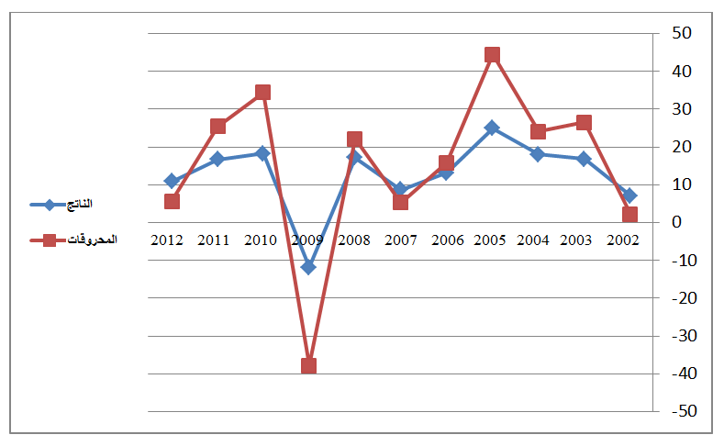
Fig.1. Figure title (this is an example of figure 1)

Source: author’s name, year, page

4. CONCLUSION
The conclusion of a research paper needs to summarize the content and purpose of the article. The conclusion of a research paper needs to summarize the content and purpose of the article. The conclusion of a research paper needs to summarize the content and purpose of the article. The conclusion of a research paper needs to summarize the content and purpose of the article. The conclusion of a research paper needs to summarize the content and purpose of the article. The conclusion of a research paper needs to summarize the content and purpose of the article.
5. Endnotes
The notes and references are numbered sequentially as they appear in the text of the text, and they are written automatically and presented at the end of the article (End of Document),the list of references at the end of the document, written in the following manner: (Times New Roman 12)
- Books : author’s name (year), full title, publishing, country;
- Theses: researcher, thesis title, college, university, country, year;
- Journal article : author’s name (year), full title of the article, review name, place, volume and number ;
- Seminar article: author’s name (year), full title of the paper, title of seminar, place and date, country ;
- Internet websites: author’s name (year), full title of the file, detailed web site : http://fulladdress (consulted on day/month/year).

6. Appendices

7. References: References should be listed at the end of the article in both English and Arabic.

Important Notes:

1- The article must be characterized by accuracy and linguistic integrity, (so that the article must not exceed 25 pages and not less than 15 pages of this size specified in the form or template of the journal).

2- The size and shape of the form must be kept the same, and copy and paste should be used to insert the content of the article into the template.

3- Every article that does not respect this template leads to the direct rejection of the article.

4- The first letters of the words of a title of an article written in a foreign language must be capitalized Example:
The Legal Status of the Environmental Refugee

5- The document on the transfer of copyrights, dated, signed and scanned, will be sent after the final acceptance of the article (that is, after the references have been included) and a notification of that is sent through the portal, to the e-mail of the journal.

jlsr@univ-msila.dz

* Important

References: References should be listed at the end of the article in both English and Arabic.

  Licensed under Creative Commons Attribution-ShareAlike 4.0 International License

